
Rajvardhan Zende
202501100016

SE1 S11

ESSENTIALS OF DATA SCIENCE


PRACTICE LAB ASSIGNMENT
5.1.1 STACKED PLOT Createa stackedareaplottovisualize the temperature variations for three different cities (City A, City B, and City C)across the monthsoftheyear.The temperature data is provided for each city in the editor.
Your task is to:
Create a stacked area plot using the data.
Label the x-axis as "Month", the y-axis as "Temperature", and provide the title "Temperature Variation" for the plot.
Display the plot showing the temperature variation for each city throughout the months of the year.

INPUT OUTPUT

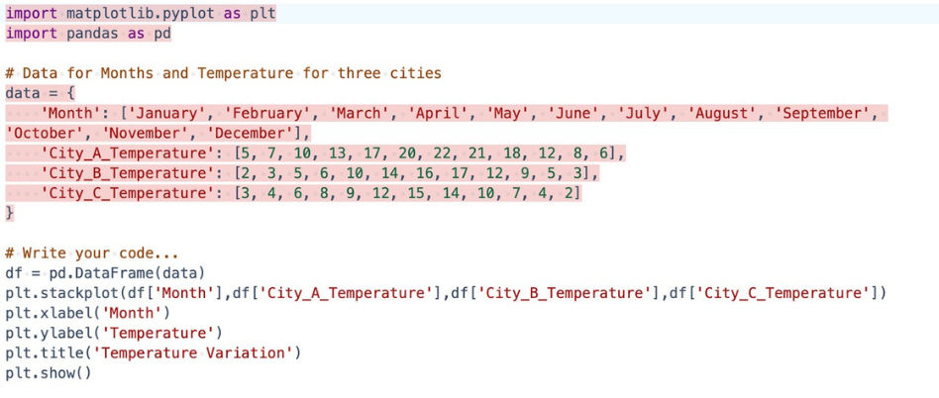

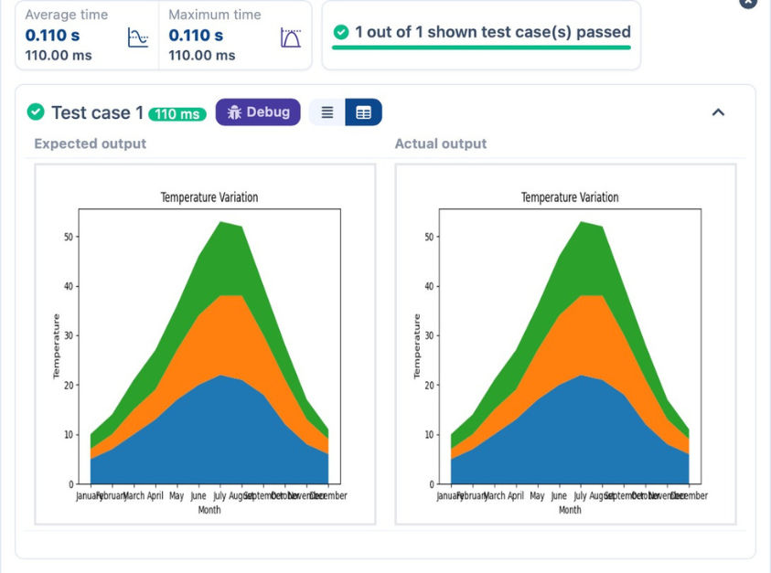




5.2.1 TITANIC DATASET
WriteaPythonprogramtoanalyzeandvisualizedatafromtheTitanicdatasetbasedonthefollowing instructions:
Dataset Information:
Thedataset is stored in aCSV filenamedtitanic.csvandhasbeenloadedusingthepandaslibrary. It contains the following columns:
Pclass: Passenger class (1 =First, 2 =Second,3=Third).
Gender: Gender of the passenger (male/female).
Age: Age of the passenger.
Survived: Survival status (0 = Did not survive, 1 = Survived).
Fare: Ticket fare paid by the passenger.
Visualization:
To represent these trends, you will create 5 visualizations using Matplotlib. The visualizations should be arranged in a 3x2 grid (3 rows and 2 columns).
Visualization Details:
Write the code to create a series of visualizations as follows:
Bar Plot (Pclass Distribution):
Create a bar plot to show the distribution of passengers across the different passenger classes (Pclass).
Use the color skyblue for the bars.
Title the plot as "Passenger Class Distribution".
Label the x-axis as "Pclass" and the y-axis as "Count".
Pie Chart (Gender Distribution):
Create a pie chart to display the distribution of male and female passengers.
Use lightblue for males and lightcoral for females.
Include percentages on the slices (use autopct='%1.1f%%').
Title the plot as "Gender Distribution".
Histogram (Age Distribution):
Create a histogram to visualize the distribution of passengers' ages.
Use lightgreen for the bars with black edges (edgecolor = 'black').
Set the number of bins to 8 for the histogram.
Title the plot as "Age Distribution".
Label the x-axis as "Age" and the y-axis as "Frequency".
Bar Plot (Survival Count):
Create a bar plot to show the count of passengers who survived and those who did not, based on the Survived column. Use the colors lightblue for survivors (1) and lightcoral for non-survivors (0).
Title the plot as "Survival Count".
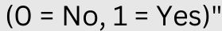Label the x-axis as "Survived (0 = No, 1 = Yes)" and the y-axis as "Count".
Scatter Plot (Fare vs Age):
Create a scatter plot to visualize the relationship between the Fare and Age of passengers.
Use orange for the data points.
Title the plot as "Fare vs Age".
Label the x-axis as "Age" and the y-axis as "Fare".
Note: Refer to the displayed plot in the sample test cases for better understanding.

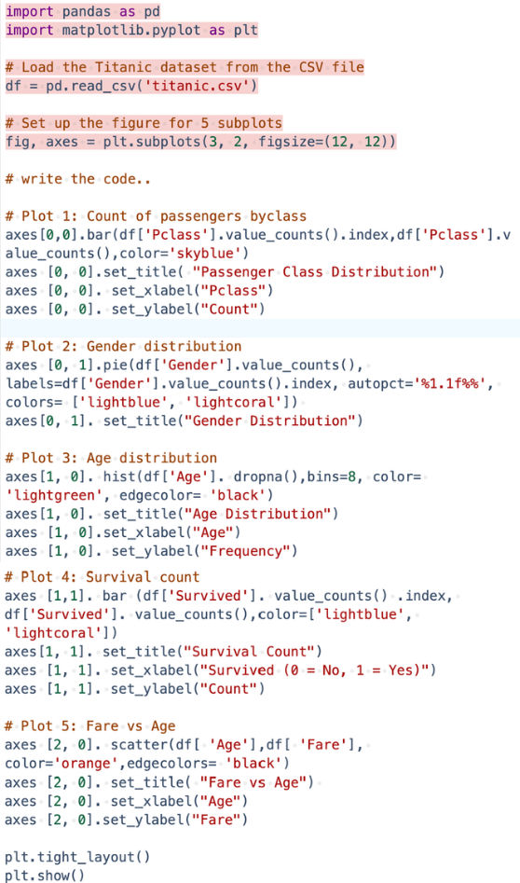
INPUT OUTPUT
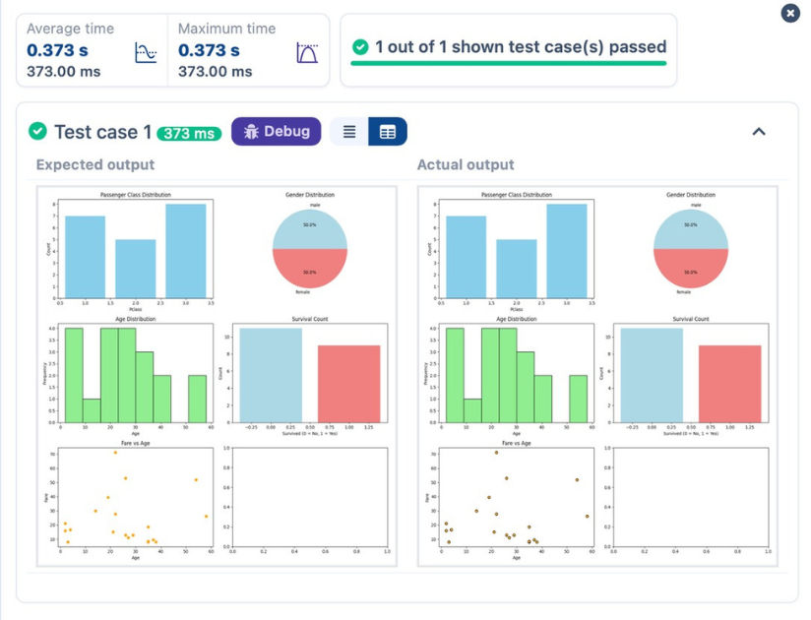

5.2.2. HISTOGRAM OF PASSENGER INFORMATION OF TITANIC
Write a Python codeto plotahistogramforthedistributionofthe'Age'columnfromtheTitanicdataset.Thehistogramshoulddisplaythefrequencyofdifferentage ranges with the following specifications:
1.Use 30 bins for the histogram.
2.Set the edge color of the bars to black (k).
3.Label the x-axis as 'Age' and the y-axis as 'Frequency'.
4.Add the title "Age Distribution" to the histogram.
The Titanic dataset contains columns as shown below,
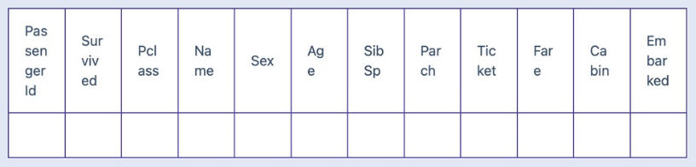
Sample Data:
PassengerId,Survived,Pclass,Name,Sex,Age,SibSp,Parch,Ticket,Fare,Cabin,Embarked
1,0,3,"Braund, Mr. Owen Harris",male,22,1,0,A/5 21171,7.25,,S
2,1,1,"Cumings, Mrs. John Bradley (Florence Briggs Thayer)",female,38,1,0,PC 17599,71.2833,C85,C 3,1,3,"Heikkinen, Miss. Laina",female,26,0,0,STON/O2. 3101282,7.925,,S
4,1,1,"Futrelle, Mrs. Jacques Heath (Lily May Peel)",female,35,1,0,113803,53.1,C123,S
5,0,3,"Allen, Mr. William Henry",male,35,0,0,373450,8.05,,S
6,0,3,"Moran, Mr. James",male,,0,0,330877,8.4583,,Q
7,0,1,"McCarthy, Mr. Timothy J",male,54,0,0,17463,51.8625,E46,S
8,0,3,"Palsson, Master. Gosta Leonard",male,2,3,1,349909,21.075,,S
9,1,3,"Johnson, Mrs. Oscar W (Elisabeth Vilhelmina Berg)",female,27,0,2,347742,11.1333,,S 10,1,2,"Nasser, Mrs. Nicholas (Adele Achem)",female,14,1,0,237736,30.0708,,C

INPUT OUTPUT
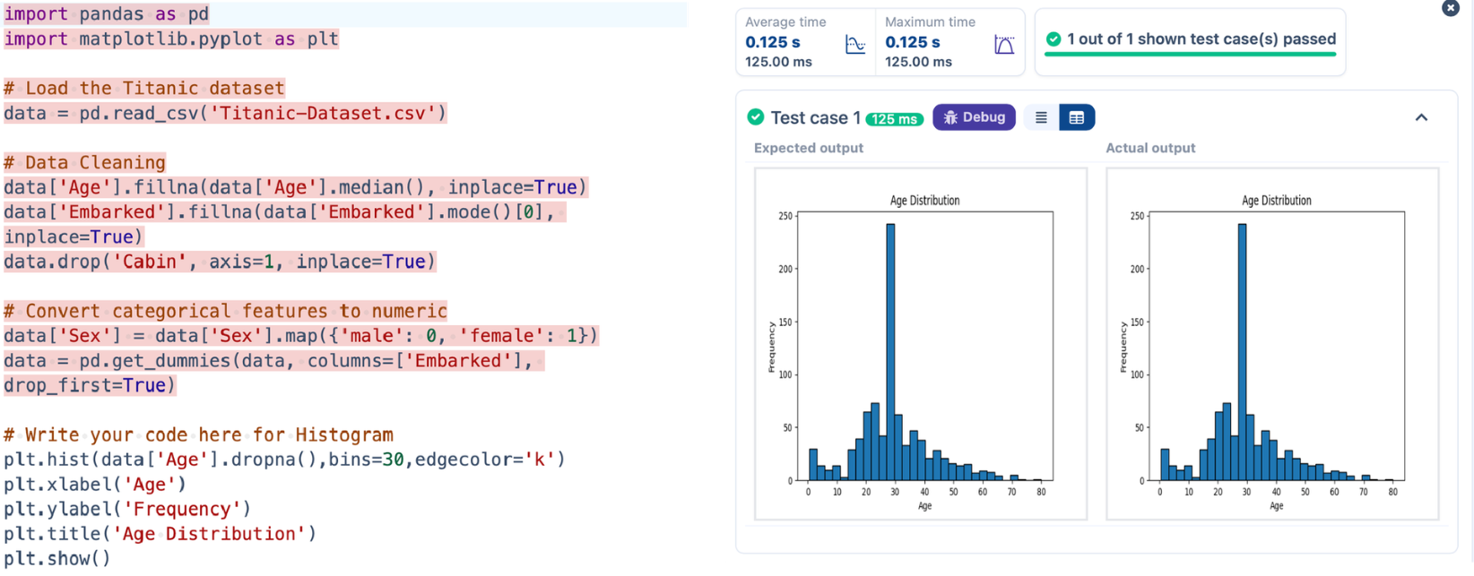

5.2.3. BAR PLOT OF SURVIVAL RATE OF PASSENGERS
Writea Pythoncodeto plotabar chart thatshows thecountof passengerswhosurvivedanddidnotsurviveintheTitanicdataset.Thechartshoulddisplaythe following specifications:
1.Use the 'Survived' column to show the count of survivors (0 = Did not survive, 1 = Survived).
2.Set the chart type to 'bar'.
3.Add the title "Survival Count" to the chart.
4.Label the x-axis as 'Survived' and the y-axis as 'Count'.
The Titanic dataset contains columns as shown below,
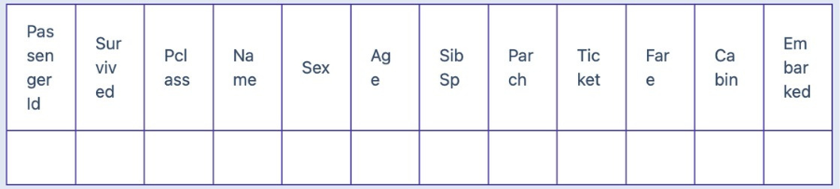
Sample Data:
PassengerId,Survived,Pclass,Name,Sex,Age,SibSp,Parch,Ticket,Fare,Cabin,Embarked
1,0,3,"Braund, Mr. Owen Harris",male,22,1,0,A/5 21171,7.25,,S
2,1,1,"Cumings, Mrs. John Bradley (Florence Briggs Thayer)",female,38,1,0,PC 17599,71.2833,C85,C 3,1,3,"Heikkinen, Miss. Laina",female,26,0,0,STON/O2. 3101282,7.925,,S
4,1,1,"Futrelle, Mrs. Jacques Heath (Lily May Peel)",female,35,1,0,113803,53.1,C123,S
5,0,3,"Allen, Mr. William Henry",male,35,0,0,373450,8.05,,S
6,0,3,"Moran, Mr. James",male,,0,0,330877,8.4583,,Q
7,0,1,"McCarthy, Mr. Timothy J",male,54,0,0,17463,51.8625,E46,S
8,0,3,"Palsson, Master. Gosta Leonard",male,2,3,1,349909,21.075,,S
9,1,3,"Johnson, Mrs. Oscar W (Elisabeth Vilhelmina Berg)",female,27,0,2,347742,11.1333,,S 10,1,2,"Nasser, Mrs. Nicholas (Adele Achem)",female,14,1,0,237736,30.0708,,C

INPUT OUTPUT

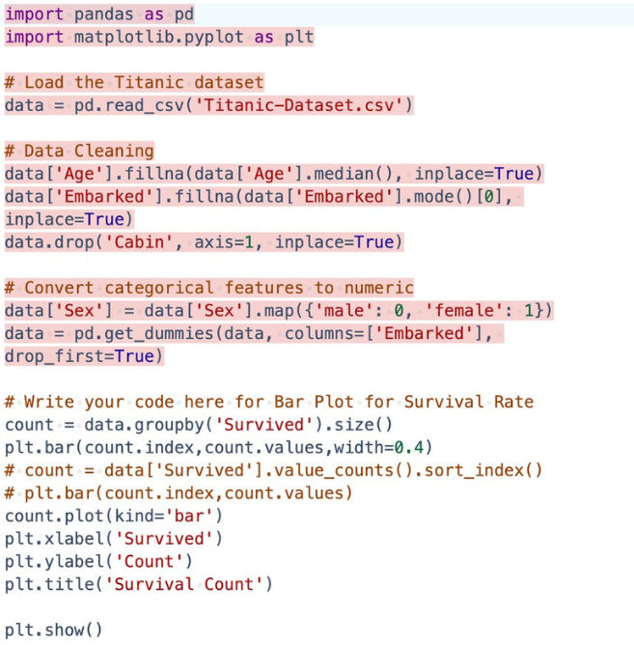

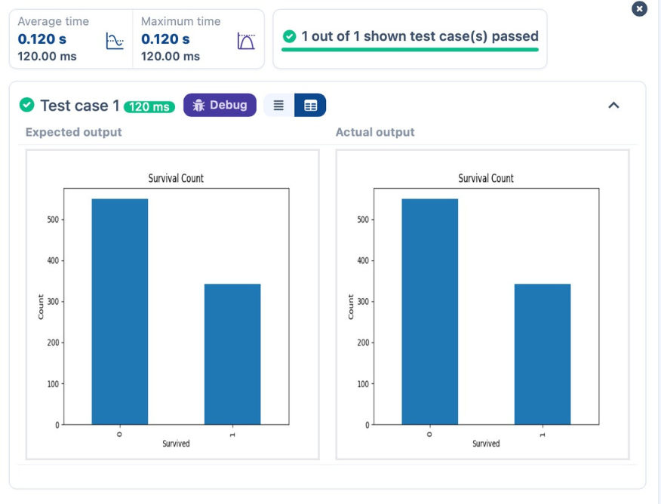

5.2.4. BAR PLOT FOR SURVIVAL BY GENDER
WriteaPython code to plotastackedbar chart thatshowsthecountofpassengerswhosurvivedanddidnotsurvive,groupedbygender, in the Titanic dataset. The chartshould display the followingspecifications:
1.Group the databy the 'Sex' column, then usethevalue_counts()functiontocounttheoccurrencesofsurvivors(0=Didnotsurvive, 1 = Survived) for each gender. 2.Use a stacked bar chart to display the survival counts.
3.Add the title "Survival by Gender" to the chart.
4.Label the x-axis as 'Gender' and the y-axis as 'Count'.
5.The legend should indicate 'Not Survived' and 'Survived'.
The Titanic dataset contains columns as shown below,
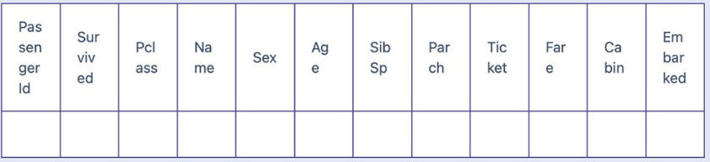
Sample Data:
PassengerId,Survived,Pclass,Name,Sex,Age,SibSp,Parch,Ticket,Fare,Cabin,Embarked
1,0,3,"Braund, Mr. Owen Harris",male,22,1,0,A/5 21171,7.25,,S
2,1,1,"Cumings, Mrs. John Bradley (Florence Briggs Thayer)",female,38,1,0,PC 17599,71.2833,C85,C 3,1,3,"Heikkinen, Miss. Laina",female,26,0,0,STON/O2. 3101282,7.925,,S
4,1,1,"Futrelle, Mrs. Jacques Heath (Lily May Peel)",female,35,1,0,113803,53.1,C123,S
5,0,3,"Allen, Mr. William Henry",male,35,0,0,373450,8.05,,S
6,0,3,"Moran, Mr. James",male,,0,0,330877,8.4583,,Q
7,0,1,"McCarthy, Mr. Timothy J",male,54,0,0,17463,51.8625,E46,S
8,0,3,"Palsson, Master. Gosta Leonard",male,2,3,1,349909,21.075,,S
9,1,3,"Johnson, Mrs. Oscar W (Elisabeth Vilhelmina Berg)",female,27,0,2,347742,11.1333,,S 10,1,2,"Nasser, Mrs. Nicholas (Adele Achem)",female,14,1,0,237736,30.0708,,C

INPUT OUTPUT

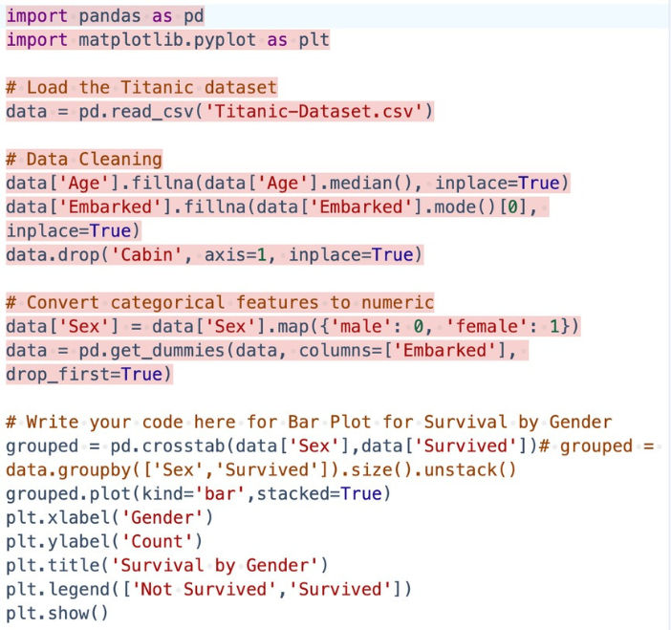

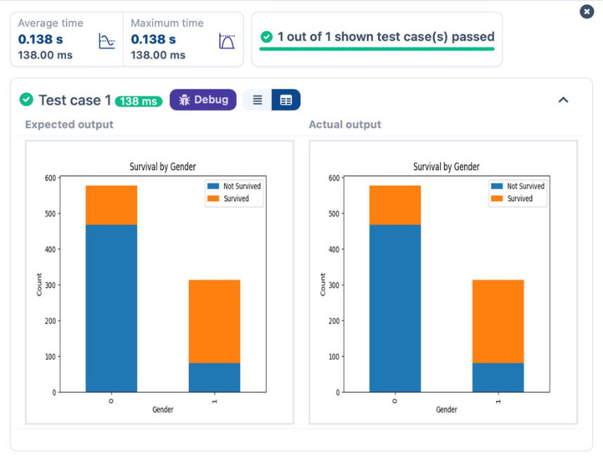

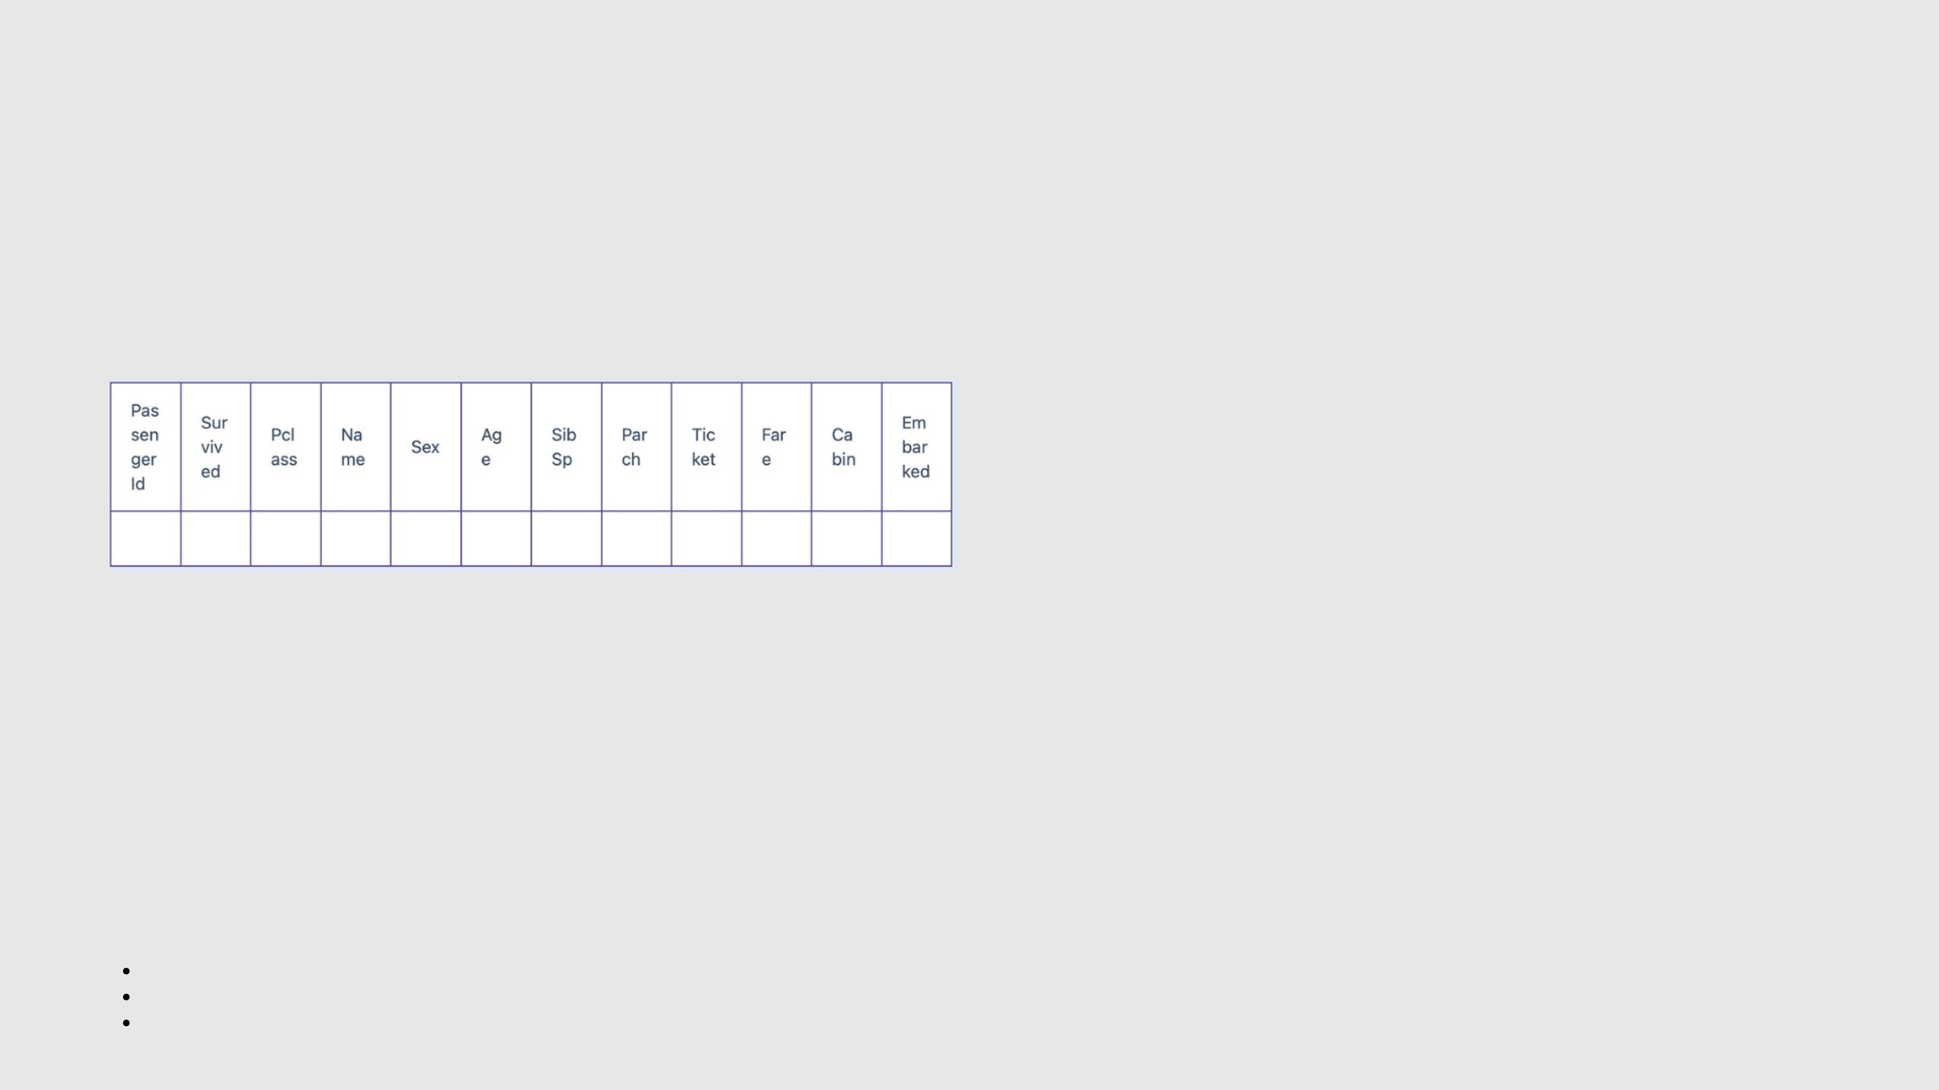
5.2.5. BAR PLOT FOR SURVIVAL BY PCLASS
Writea Python code to plotastackedbar chartthatshowsthecountofpassengers who survivedanddidnotsurvive, groupedby passenger class (Pclass), in the Titanic dataset. The chart should display the following specifications:
1.Group the data by the Pclass column and count the number of survivors (0 = Did not survive, 1 = Survived) for each class using value_counts(). 2.Use a stacked bar chart to display the survival counts.
3.Add the title "Survival by Pclass" to the chart.
4.Label the x-axis as 'Pclass' and the y-axis as 'Count'.
5.The legend should indicate 'Not Survived' and 'Survived'.
The Titanic dataset contains columns as shown below,
Sample Data:
PassengerId,Survived,Pclass,Name,Sex,Age,SibSp,Parch,Ticket,Fare,Cabin,Embarked
1,0,3,"Braund, Mr. Owen Harris",male,22,1,0,A/5 21171,7.25,,S
2,1,1,"Cumings, Mrs. John Bradley (Florence Briggs Thayer)",female,38,1,0,PC 17599,71.2833,C85,C 3,1,3,"Heikkinen, Miss. Laina",female,26,0,0,STON/O2. 3101282,7.925,,S
4,1,1,"Futrelle, Mrs. Jacques Heath (Lily May Peel)",female,35,1,0,113803,53.1,C123,S
5,0,3,"Allen, Mr. William Henry",male,35,0,0,373450,8.05,,S
6,0,3,"Moran, Mr. James",male,,0,0,330877,8.4583,,Q
7,0,1,"McCarthy, Mr. Timothy J",male,54,0,0,17463,51.8625,E46,S
8,0,3,"Palsson, Master. Gosta Leonard",male,2,3,1,349909,21.075,,S
9,1,3,"Johnson, Mrs. Oscar W (Elisabeth Vilhelmina Berg)",female,27,0,2,347742,11.1333,,S 10,1,2,"Nasser, Mrs. Nicholas (Adele Achem)",female,14,1,0,237736,30.0708,,C
Note:
Refer to the visible test case for better reference.
Ensure you use the groupby() function with value_counts() to count the survivors and non-survivors for each Pclass.
Do not manually use size() or unstack() without value_counts(). Use the value_counts() method for counting survival status directly.

INPUT OUTPUT

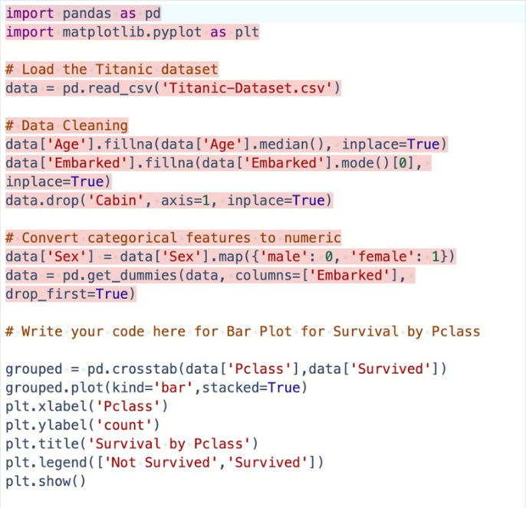

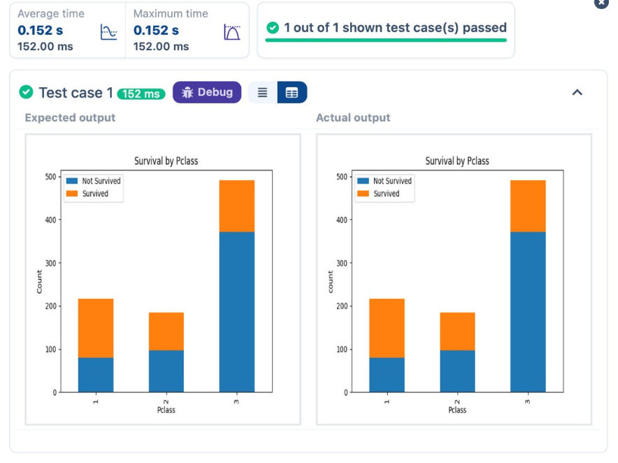

5.2.6. BAR PLOT FOR SURVIVAL BY EMBARKED
Writea Pythoncodeto plotastackedbarchart showingthesurvivalcountforpassengers basedontheirembarkationlocation intheTitanicdataset.
Thechart should display thefollowingspecifications:
1.Use the Embarked column to determine theembarkationlocation. After converting this columninto dummyvariables (usingpd.get_dummies()), plot the survival count based on the Embarked_Q column (representing passengers who embarked from Queenstown) in relation to survival.
2.Set the chart type to 'bar' and make it stacked.
3.Add the title "Survival by Embarked " to the chart.
4.Label the x-axis as 'Embarked' and the y-axis as 'Count'.
5.Include a legend to distinguish between survivors and non-survivors (label the legend as 'Survived' and 'Not Survived').
The Titanic dataset contains columns as shown below,

Sample Data:
PassengerId,Survived,Pclass,Name,Sex,Age,SibSp,Parch,Ticket,Fare,Cabin,Embarked
1,0,3,"Braund, Mr. Owen Harris",male,22,1,0,A/5 21171,7.25,,S
2,1,1,"Cumings, Mrs. John Bradley (Florence Briggs Thayer)",female,38,1,0,PC 17599,71.2833,C85,C 3,1,3,"Heikkinen, Miss. Laina",female,26,0,0,STON/O2. 3101282,7.925,,S
4,1,1,"Futrelle, Mrs. Jacques Heath (Lily May Peel)",female,35,1,0,113803,53.1,C123,S
5,0,3,"Allen, Mr. William Henry",male,35,0,0,373450,8.05,,S
6,0,3,"Moran, Mr. James",male,,0,0,330877,8.4583,,Q
7,0,1,"McCarthy, Mr. Timothy J",male,54,0,0,17463,51.8625,E46,S
8,0,3,"Palsson, Master. Gosta Leonard",male,2,3,1,349909,21.075,,S
9,1,3,"Johnson, Mrs. Oscar W (Elisabeth Vilhelmina Berg)",female,27,0,2,347742,11.1333,,S 10,1,2,"Nasser, Mrs. Nicholas (Adele Achem)",female,14,1,0,237736,30.0708,,C

INPUT OUTPUT

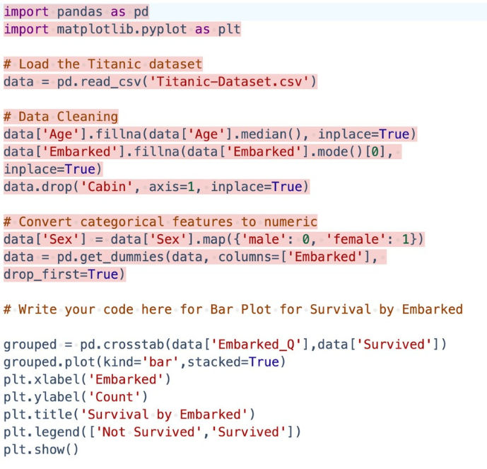

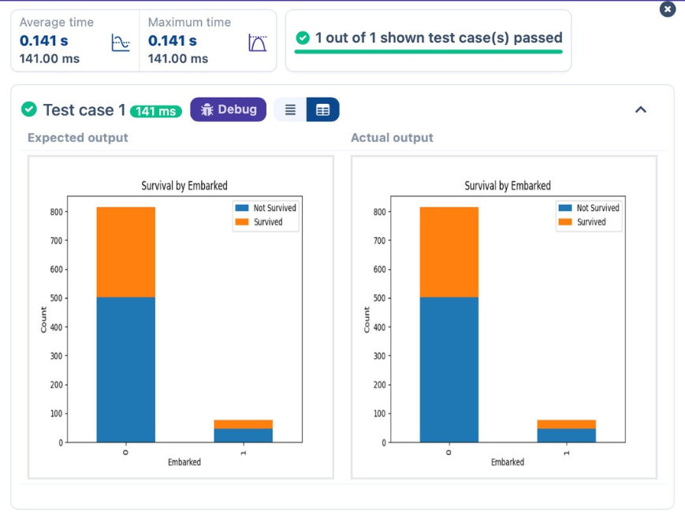

5.2.7. BOX PLOT FOR AGE DISTRIBUTION
Writea Pythoncode to plot a boxplotthatshowsthedistributionofthe'Age'columnfromtheTitanicdatasetacrossdifferentpassenger classes. The boxplot should display the following specifications:
1.Use the Pclass column to group the data for the boxplot.
2.Set the title of the plot to "Age by Pclass".
3.Remove the default subtitle with plt.suptitle('').
4.Label the x-axis as 'Pclass' and the y-axis as 'Age'.
The Titanic dataset contains columns as shown below,

Sample Data:
PassengerId,Survived,Pclass,Name,Sex,Age,SibSp,Parch,Ticket,Fare,Cabin,Embarked
1,0,3,"Braund, Mr. Owen Harris",male,22,1,0,A/5 21171,7.25,,S
2,1,1,"Cumings, Mrs. John Bradley (Florence Briggs Thayer)",female,38,1,0,PC 17599,71.2833,C85,C 3,1,3,"Heikkinen, Miss. Laina",female,26,0,0,STON/O2. 3101282,7.925,,S
4,1,1,"Futrelle, Mrs. Jacques Heath (Lily May Peel)",female,35,1,0,113803,53.1,C123,S
5,0,3,"Allen, Mr. William Henry",male,35,0,0,373450,8.05,,S
6,0,3,"Moran, Mr. James",male,,0,0,330877,8.4583,,Q
7,0,1,"McCarthy, Mr. Timothy J",male,54,0,0,17463,51.8625,E46,S
8,0,3,"Palsson, Master. Gosta Leonard",male,2,3,1,349909,21.075,,S
9,1,3,"Johnson, Mrs. Oscar W (Elisabeth Vilhelmina Berg)",female,27,0,2,347742,11.1333,,S 10,1,2,"Nasser, Mrs. Nicholas (Adele Achem)",female,14,1,0,237736,30.0708,,C

INPUT OUTPUT

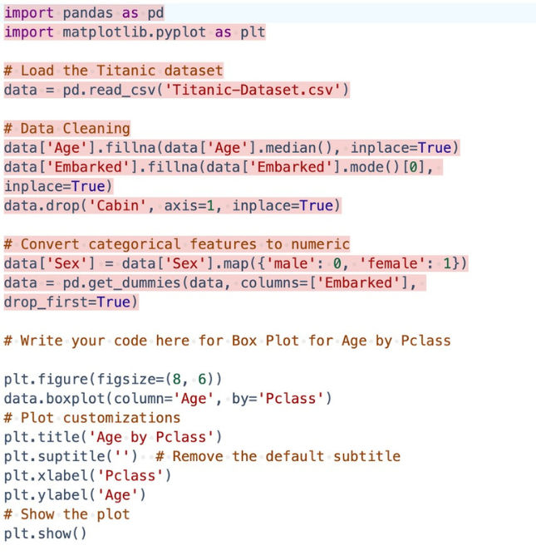

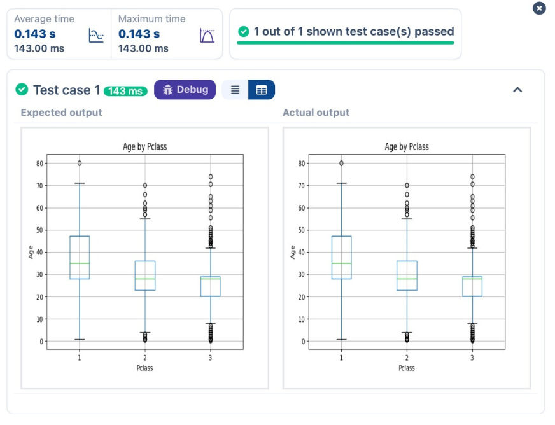

5.2.8. BOX PLOT FOR AGE BY SURVIVED
Writea Python code to plot a boxplot that shows the distribution ofthe 'Age'column fromtheTitanicdatasetbasedonwhether passengers survived or not. The boxplot should display the following specifications:
1.Use the Survived column to group the data for the boxplot (0 = Did not survive, 1 = Survived).
2.Set the title of the plot to "Age by Survival".
3.Remove the default subtitle with plt.suptitle('').
4.Label the x-axis as 'Survived' and the y-axis as 'Age'.
The Titanic dataset contains columns as shown below,

Sample Data:
PassengerId,Survived,Pclass,Name,Sex,Age,SibSp,Parch,Ticket,Fare,Cabin,Embarked
1,0,3,"Braund, Mr. Owen Harris",male,22,1,0,A/5 21171,7.25,,S
2,1,1,"Cumings, Mrs. John Bradley (Florence Briggs Thayer)",female,38,1,0,PC 17599,71.2833,C85,C 3,1,3,"Heikkinen, Miss. Laina",female,26,0,0,STON/O2. 3101282,7.925,,S
4,1,1,"Futrelle, Mrs. Jacques Heath (Lily May Peel)",female,35,1,0,113803,53.1,C123,S
5,0,3,"Allen, Mr. William Henry",male,35,0,0,373450,8.05,,S
6,0,3,"Moran, Mr. James",male,,0,0,330877,8.4583,,Q
7,0,1,"McCarthy, Mr. Timothy J",male,54,0,0,17463,51.8625,E46,S
8,0,3,"Palsson, Master. Gosta Leonard",male,2,3,1,349909,21.075,,S
9,1,3,"Johnson, Mrs. Oscar W (Elisabeth Vilhelmina Berg)",female,27,0,2,347742,11.1333,,S 10,1,2,"Nasser, Mrs. Nicholas (Adele Achem)",female,14,1,0,237736,30.0708,,C

INPUT OUTPUT

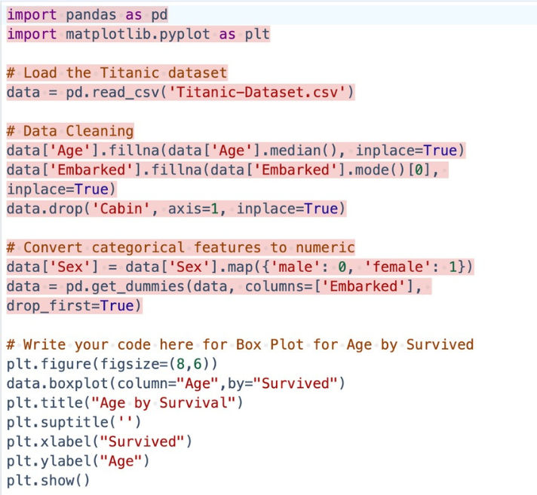

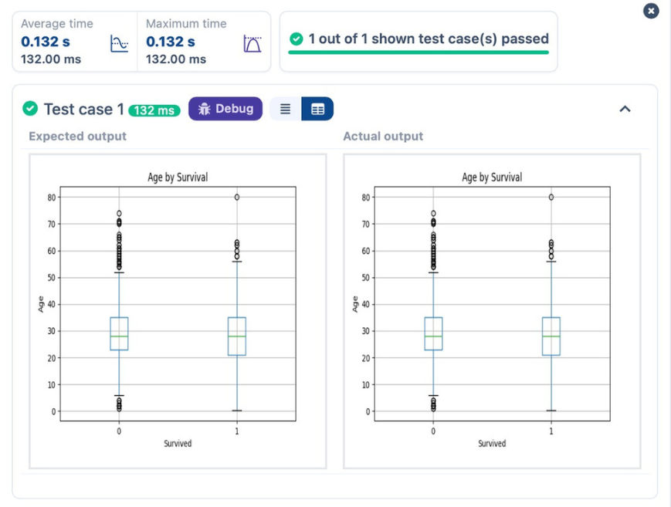

5.2.9. BOX PLOT FOR FARE BY PCLASS
Writea Python code toplot a boxplotthatshowsthedistributionofthe'Fare'columnfromtheTitanicdatasetbasedonthe passenger class (Pclass). The boxplot should display the following specifications:
1.Use the Pclass column to group the data for the boxplot.
2.Set the title of the plot to "Fare by Pclass".
3.Remove the default subtitle with plt.suptitle('').
4.Label the x-axis as 'Pclass' and the y-axis as 'Fare'.
The Titanic dataset contains columns as shown below,

Sample Data:
PassengerId,Survived,Pclass,Name,Sex,Age,SibSp,Parch,Ticket,Fare,Cabin,Embarked
1,0,3,"Braund, Mr. Owen Harris",male,22,1,0,A/5 21171,7.25,,S
2,1,1,"Cumings, Mrs. John Bradley (Florence Briggs Thayer)",female,38,1,0,PC 17599,71.2833,C85,C 3,1,3,"Heikkinen, Miss. Laina",female,26,0,0,STON/O2. 3101282,7.925,,S
4,1,1,"Futrelle, Mrs. Jacques Heath (Lily May Peel)",female,35,1,0,113803,53.1,C123,S
5,0,3,"Allen, Mr. William Henry",male,35,0,0,373450,8.05,,S
6,0,3,"Moran, Mr. James",male,,0,0,330877,8.4583,,Q
7,0,1,"McCarthy, Mr. Timothy J",male,54,0,0,17463,51.8625,E46,S
8,0,3,"Palsson, Master. Gosta Leonard",male,2,3,1,349909,21.075,,S
9,1,3,"Johnson, Mrs. Oscar W (Elisabeth Vilhelmina Berg)",female,27,0,2,347742,11.1333,,S 10,1,2,"Nasser, Mrs. Nicholas (Adele Achem)",female,14,1,0,237736,30.0708,,C

INPUT OUTPUT

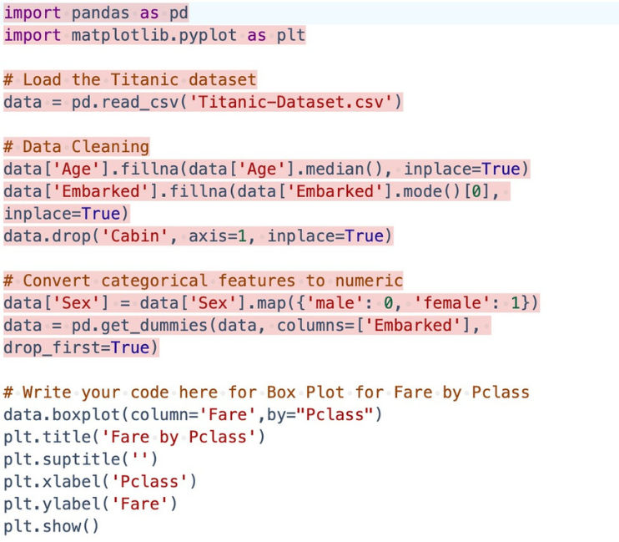

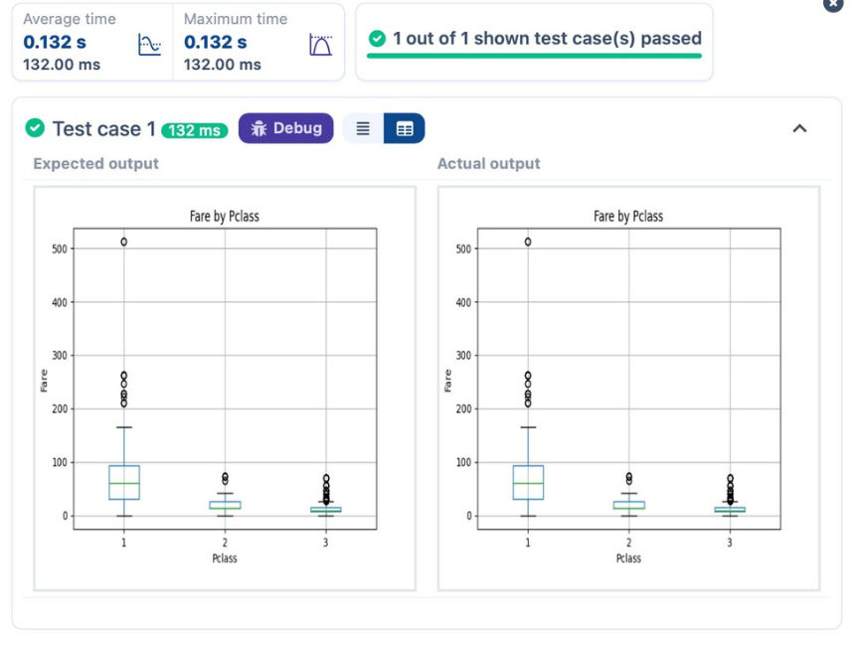

5.2.10. SCATTER PLOT FOR AGE VS. FARE
Writea Python codeto plot ascatter plot showing therelationshipbetweenthe'Age'and'Fare'columnsintheTitanicdataset.The scatter plot should display the following specifications:
1.Use the Age column for the x-axis and the Fare column for the y-axis.
2.Set the title of the plot to "Age vs. Fare".
3.Label the x-axis as 'Age' and the y-axis as 'Fare'.
The Titanic dataset contains columns as shown below,

Sample Data:
PassengerId,Survived,Pclass,Name,Sex,Age,SibSp,Parch,Ticket,Fare,Cabin,Embarked
1,0,3,"Braund, Mr. Owen Harris",male,22,1,0,A/5 21171,7.25,,S
2,1,1,"Cumings, Mrs. John Bradley (Florence Briggs Thayer)",female,38,1,0,PC 17599,71.2833,C85,C 3,1,3,"Heikkinen, Miss. Laina",female,26,0,0,STON/O2. 3101282,7.925,,S
4,1,1,"Futrelle, Mrs. Jacques Heath (Lily May Peel)",female,35,1,0,113803,53.1,C123,S
5,0,3,"Allen, Mr. William Henry",male,35,0,0,373450,8.05,,S
6,0,3,"Moran, Mr. James",male,,0,0,330877,8.4583,,Q
7,0,1,"McCarthy, Mr. Timothy J",male,54,0,0,17463,51.8625,E46,S
8,0,3,"Palsson, Master. Gosta Leonard",male,2,3,1,349909,21.075,,S
9,1,3,"Johnson, Mrs. Oscar W (Elisabeth Vilhelmina Berg)",female,27,0,2,347742,11.1333,,S 10,1,2,"Nasser, Mrs. Nicholas (Adele Achem)",female,14,1,0,237736,30.0708,,C

INPUT OUTPUT

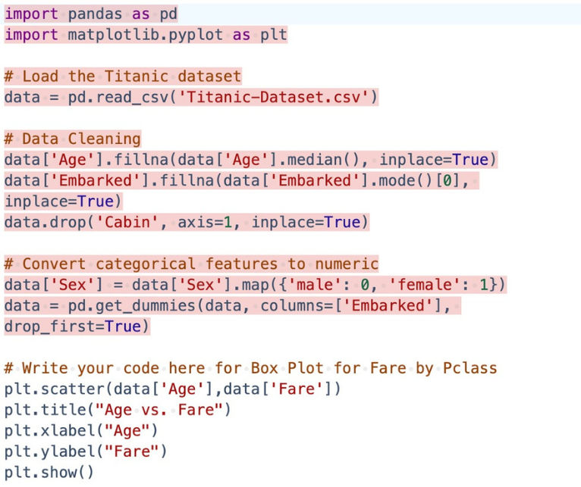

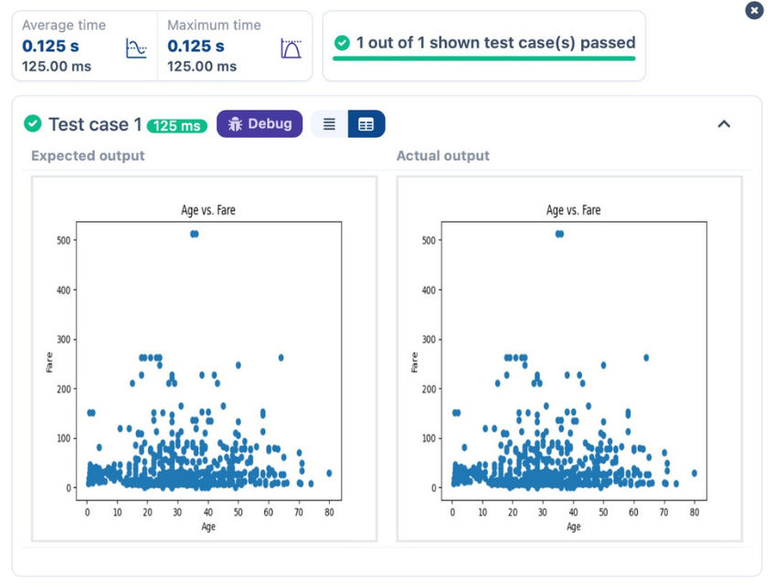

5.2.11. SCATTER PLOT FOR AGE VS. FARE BY SURVIVED
Writea Python code to plot a scatter plot showing therelationshipbetweenthe'Age'and'Fare'columnsintheTitanicdataset,withpointscolor-codedbysurvival status. The scatter plot should display the following specifications:
1.Use the Age column for the x-axis and the Fare column for the y-axis.
2.Color the points based on the Survived column: Red for passengers who did not survive (Survived = 0). Blue for passengers who survived (Survived = 1). 3.Set the title of the plot to "Age vs. Fare by Survival".
4.Label the x-axis as 'Age' and the y-axis as 'Fare'.
The Titanic dataset contains columns as shown below,

Sample Data:
PassengerId,Survived,Pclass,Name,Sex,Age,SibSp,Parch,Ticket,Fare,Cabin,Embarked
1,0,3,"Braund, Mr. Owen Harris",male,22,1,0,A/5 21171,7.25,,S
2,1,1,"Cumings, Mrs. John Bradley (Florence Briggs Thayer)",female,38,1,0,PC 17599,71.2833,C85,C 3,1,3,"Heikkinen, Miss. Laina",female,26,0,0,STON/O2. 3101282,7.925,,S
4,1,1,"Futrelle, Mrs. Jacques Heath (Lily May Peel)",female,35,1,0,113803,53.1,C123,S
5,0,3,"Allen, Mr. William Henry",male,35,0,0,373450,8.05,,S
6,0,3,"Moran, Mr. James",male,,0,0,330877,8.4583,,Q
7,0,1,"McCarthy, Mr. Timothy J",male,54,0,0,17463,51.8625,E46,S
8,0,3,"Palsson, Master. Gosta Leonard",male,2,3,1,349909,21.075,,S
9,1,3,"Johnson, Mrs. Oscar W (Elisabeth Vilhelmina Berg)",female,27,0,2,347742,11.1333,,S 10,1,2,"Nasser, Mrs. Nicholas (Adele Achem)",female,14,1,0,237736,30.0708,,C

INPUT OUTPUT

